**Time Efficient Ultrasound Localization Microscopy (TEULM)**

The diffraction limit has long represented an unreachable summit to conquer in ultrasound imaging until the inventory of ultrasound localization microscopy (ULM). In ultrasound B-mode imaging, the spatial resolution is typically around one wavelength () of the ultrasound waves used for imaging. In ULM, however, the spatial resolution is improved by 10 times to 0.1. Typical processing steps are summarized in Figure 1. B-mode (raw) images of the vessels filled with microbubble of low concentration are acquired at a very high frame rate (typically 1000 frames per second). Raw images may be filtered to retain microbubble signals by removing tissue motion and background signals. Then the bubbles are localized whose center are tracked frame by frame. By interpolating all the tracks retrieved from each image and accumulating them to the same image grid of fine pixel size and counting the number of tracks passing through each pixel, a super-resolved vasculature image is reconstructed (Figure 2).

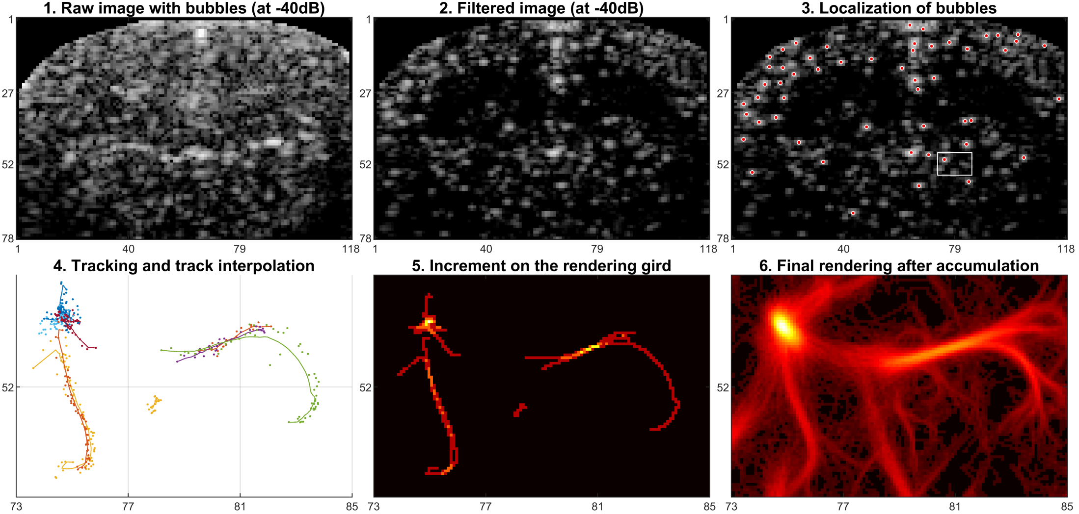

Figure 1 ULM processing steps [1]

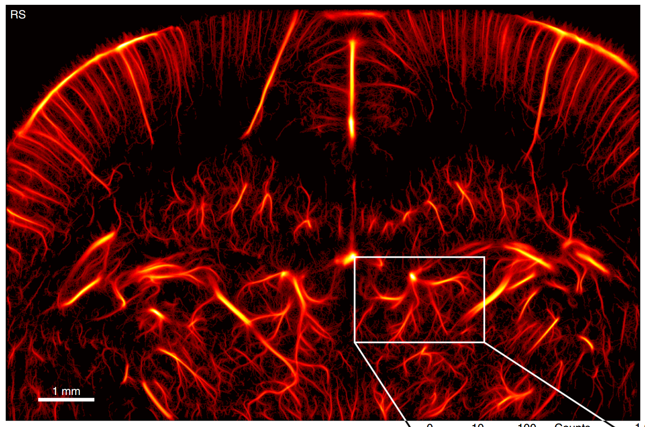

Figure 2 ULM of the living rat brain [1]

One may notice that, in ULM, the images need to be acquired at a very high frame rate, imposing high requirement to the ultrasound hardware. In this project, we will implement an interpolation method that will ease this requirement on high frame rate [2]. Given the dataset acquired at 1000 Hz frame rate. You will first down sample (DS) the frame rate by a factor of DS=2 (500 Hz), DS =4 (250 Hz), DS=10 (100 Hz), and implement the radial basis function (RBF) 2D interpolation to upsample the dataset to 1000 Hz frame rate and compare the reconstructed ULM images to that from the provided dataset acquired at 1000 Hz. The steps in RBF 2D interpolation have been detailed in Ref [2] Sec II and Ref [3] Sec II and are briefly summarized as follows:

1. Construct the RBFs matrix and form the vectorized image intensity data **F** with the down sampled data, then the interpolation coefficients vector **B** can be found according to Eq (5) in Ref[2]. You may use either Multiquadric (MQ) or Gaussian (GA) functions as RBFs.
2. Given **B**, construct a new RBFs matrix **H** for interpolation and apply Eq (6) to upsample the dataset to a frame rate of 1000 Hz, resulting **F**est. Note that the dimension of **H** needs to meet the requirement for upsampling the dataset to 1000 Hz frame rate.

After that, apply the provided example code for ULM image reconstruction (use the default parameters for image reconstruction) as the following steps are the same in ULM and TEULM. You need to compare the images reconstructed using ULM and TEULM for each down sampled dataset, i.e., ULM-500 Hz vs TEULM-1000 Hz (interpolated using the dataset-500 Hz), ULM-250 Hz vs TEULM-1000 Hz (interpolated using the dataset-250 Hz) and ULM-100 Hz vs TEULM-1000 Hz (interpolated using the dataset-100 Hz) (see Fig 3 for the expected comparison of the images).

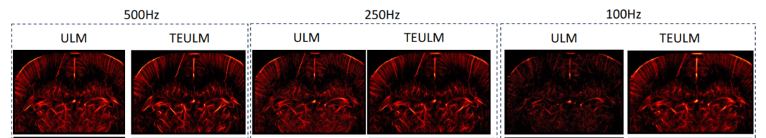

Fig. 3 [2]

1. Compute and summarize Dice score, RMSE as compared to the ULM-1000 Hz image (reference) for different DS. Expected results have been shown in Table V and Fig. 7 of Ref.[2].
2. Explore which basis function works better, MQ, Gaussion or else. (Bonus)

Notes:

a) one may need to carefully read Ref [3] (Particularly Algorithm 1) to better understand how to implement the method.

b) the input and output dataset of the interpolation is IQ data (complex signal).

c) may need to tune the shape parameter in the RBFs for optimal interpolation results.

d) the provided dataset (link attached below, extract the compressed zip files IQ_part1, IQ_part2 and IQ_part3 and put the data in the folder ‘\ TEULM\PALA_data_InVivoRatBrain\IQ’) was acquired at 1000 Hz for 192 seconds (240*800=192000 frames). For downsampling the dataset to 500 Hz, 250 Hz, 100 Hz, you need to keep only 1 frame in every 2, 4, 10 frames from the provided dataset, respectively.

**References**

[1] B. Heiles et al. "Performance benchmarking of microbubble-localization algorithms for ultrasound localization microscopy." Nature Biomedical Engineering (2022): 1-12.

[2] G. Tuccio et al. “Time Efficient Ultrasound Localization Microscopy Based on A Novel Radial Basis Function 2D Interpolation.” IEEE Transactions on Medical Imaging (2023) 43(5):1690-1701.

[3] Hamed Jalilian et al. “Increasing frame rate of echocardiography based on a novel 2D spatio-temporal meshless interpolation.” Ultrasonics (2023) 131:106953.

**Links to the provided dataset**

IQ_part1.zip: https://epan.shanghaitech.edu.cn/l/vFlmWW

IQ_part2.zip: https://epan.shanghaitech.edu.cn/l/0FK5SJ

IQ_part3.zip: https://epan.shanghaitech.edu.cn/l/bF3nGS